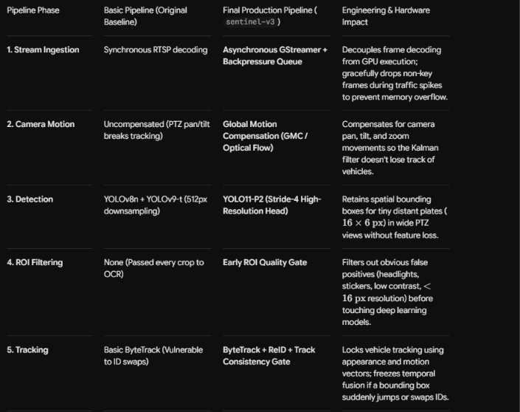

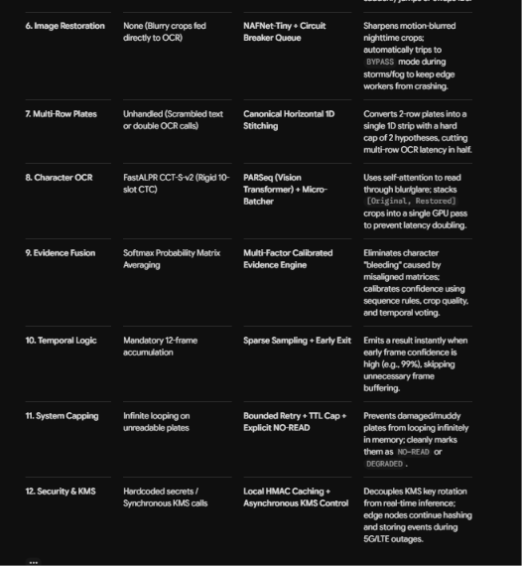

The 10 Critical Fixes & Why They Were Made
1. Detection Feature Loss $→$ Stride-4 P2 Pyramid Head
- The Fix: Replaced standard 512px downsampling with a shallower P2 detection head ($160×160$ feature map resolution at stride 4).
- Why: In wide PTZ highway streams, distant plates shrink to $16×6$ pixels. Standard P3/P4/P5 heads downsample these tiny regions until they disappear into single feature cells. P2 keeps small spatial structures intact.
2. GPU Warp Divergence $→$ Dynamic Micro-Batcher
- The Fix: Replaced dynamic if/else branching with a Calibrated Micro-Batcher.
- Why: Running restoration on some crops while skipping others causes thread desynchronization in TensorRT. Stacking [Original, Restored] crops into a unified micro-batch (e.g., batch size of 2) executes both hypotheses in a single forward pass on the GPU without doubling execution time.
3. Queue Saturation (Rain/Fog Crashes) $→$ Restoration Circuit Breaker
- The Fix: Added a backpressure monitor that trips NAFNet to BYPASS when the queue capacity hits $80\%$.
- Why: Bad weather or heavy fog makes every frame "degraded." Without a circuit breaker, the restoration queue fills up, exhausts VRAM, and crashes the edge node. Bypassing restoration preserves $100\%$ system uptime.
4. ID Swaps in Heavy Traffic $→$ Track Consistency Gate
- The Fix: Inserted a spatial and motion validation gate before temporal fusion.
- Why: In dense congestion, ByteTrack can swap IDs between adjacent vehicles (e.g., a car and a motorcycle). The gate detects sudden jumps in aspect ratio or motion vectors, flags the tracklet as SUSPICIOUS, and freezes temporal fusion to prevent corrupting the database.
5. Double-Row OCR Latency $→$ Canonical 1D Representation (Max 2 Hypotheses)
- The Fix: Sliced double-row plates (common on commercial vehicles and motorcycles) and horizontally concatenated them into a single 1D strip with a hard limit of 2 layout hypotheses.
- Why: Running OCR separately on top and bottom rows doubles GPU processing time per vehicle. Stitching into a 1D strip allows PARSeq to read the full plate in a single pass while preventing a combinatorial explosion of crop variations.
6. Slot Misalignment ("Entropy Inflation") $→$ Multi-Factor Track Voting
- The Fix: Replaced raw softmax probability matrix averaging with Track-Level Character Evidence Voting.
- Why: Minor bounding-box jitter between moving frames shifts character alignment. Averaging misaligned probability matrices causes character "bleeding," driving scores below the acceptance threshold. Voting on discrete output tokens eliminates alignment sensitivity.
7. Hallucinated Characters $→$ Dual-Hypothesis Cross-Verification
- The Fix: Cross-verified character sequence predictions from the Restored crop against the raw Original crop.
- Why: Neural restoration models (like NAFNet) can sharpen random visual noise into a clean, fake character. Requiring agreement between restored features and original pixels eliminates false positives.
8. Network-Induced Edge Lockup $→$ Offline Local HMAC Caching
- The Fix: Decoupled Key Management Service (KMS) key rotation from the real-time inference loop.
- Why: If an edge worker on an isolated highway bridge loses its 5G/LTE connection, making synchronous API calls to a central KMS for HMAC key generation will freeze the pipeline thread. Local key caching ensures uninterrupted offline processing.
9. Unnecessary Latency Delays $→$ Sparse OCR & Early Exit
- The Fix: Added early-exit logic to the temporal fusion buffer.
- Why: Mandatory 12-frame accumulation forces clean, obvious plates to wait 400ms before emitting an event. If the first two frames yield high confidence and match state layout rules, the system exits early and emits the payload immediately.
10. Memory Leaks on Dirty Plates $→$ Bounded Retry & Explicit NO-READ State
- The Fix: Implemented hard attempt caps/TTL limits that transition unreadable plates into an explicit NO-READ or DEGRADED event.
- Why: Mud-covered, physically broken, or custom-font plates can cause infinite processing loops. Enforcing a strict attempt budget gracefully purges unreadable tracks from memory.

THE NEW PIPELINE

┌───────────────────────────────────────────────────────────────────┐
│ SENTINEL GUJARAT │
│ Edge AI System for Tiny / Blurred Indian License Plates │
└───────────────────────────────────────────────────────────────────┘
│
▼
┌───────────────────────────────────────────────────────────────────┐
│ 1. MULTI-CAMERA CCTV / PTZ RTSP INGESTION │
│ │
│ • Multiple RTSP streams │
│ • GStreamer hardware decoding │
│ • Shared stream scheduler │
│ • Frame sampling / dropping under overload │
└──────────────────────────────┬────────────────────────────────────┘
▼
┌───────────────────────────────────────────────────────────────────┐
│ 2. PTZ / GLOBAL CAMERA MOTION COMPENSATION │
│ │
│ • PTZ telemetry when available │
│ • Optical-flow / affine global-motion estimation otherwise │
│ • Prevents camera pan/zoom from corrupting tracking │
└──────────────────────────────┬────────────────────────────────────┘
▼
┌───────────────────────────────────────────────────────────────────┐
│ 3. YOLO11-P2 DETECTION │
│ │
│ • Vehicle detection │
│ • License-plate detection │
│ • P2 / stride-4 feature path for small plates │
└──────────────────────────────┬────────────────────────────────────┘
▼
┌───────────────────────────────────────────────────────────────────┐
│ 4. PLATE ROI QUALITY GATE │
│ │
│ • Detection confidence │
│ • Minimum usable resolution │
│ • Aspect ratio / geometry │
│ • Blur / contrast / exposure │
│ • Reject obvious false ROIs │
│ │
│ Insufficient visual evidence ───────────────► NO-READ │
└──────────────────────────────┬────────────────────────────────────┘
▼
┌───────────────────────────────────────────────────────────────────┐
│ 5. TRACKING + TRACK RECOVERY │
│ │
│ ByteTrack │
│ + Kalman motion prediction │
│ + IoU / spatial consistency │
│ + aspect-ratio consistency │
│ + lightweight appearance/ReID │
│ + tracklet recovery │
│ │
│ Track consistency gate prevents incorrect temporal fusion │
└──────────────────────────────┬────────────────────────────────────┘
▼
┌────────────────────┐
│ PLATE TRACK ROI │
└─────────┬──────────┘
▼
┌───────────────────────────────────────────────────────────────────┐
│ 6. QUALITY + PLATE-LAYOUT ASSESSMENT │
│ │
│ Determine: │
│ • Clean / degraded │
│ • Single-row / double-row │
│ • Perspective severity │
└──────────────────────────────┬────────────────────────────────────┘
│
┌─────────────┴─────────────┐
▼ ▼
CLEAN CROP DEGRADED CROP
│ │
│ ▼
│ RESTORATION QUEUE
│ │
│ NAFNet-Tiny
│ │
│ RESTORED CROP
│ │
└─────────────┬─────────────┘
▼
┌───────────────────────────────────────────────────────────────────┐
│ 7. ONE-TIME GEOMETRIC RECTIFICATION │
│ │
│ • Estimate plate geometry │
│ • Apply one perspective transformation │
│ • Avoid repeated crop → warp → crop → warp operations │
└──────────────────────────────┬────────────────────────────────────┘
▼
┌───────────────────────────────────────────────────────────────────┐
│ 8. CANONICAL PLATE REPRESENTATION │
│ │
│ Single-row: │
│ → normalized horizontal strip │
│ │
│ Double-row: │
│ → layout assessment │
│ → bounded hypotheses │
│ → canonical representation │
│ │
│ Maximum 2 layout hypotheses — no combinatorial explosion │
└──────────────────────────────┬────────────────────────────────────┘
▼
┌───────────────────────────────────────────────────────────────────┐
│ 9. FIRST OCR / OCR REQUEST GENERATION │
│ │
│ Clean / clear crop │
│ → Original OCR request │
│ │
│ Degraded crop │
│ → Original hypothesis │
│ → Restored hypothesis │
│ │
│ Only ambiguous/degraded cases require dual-hypothesis OCR │
└──────────────────────────────┬────────────────────────────────────┘
▼
┌───────────────────────────────────────────────────────────────────┐
│ 10. DYNAMIC OCR MICRO-BATCHER │
│ │
│ OCR REQUEST QUEUE │
│ │ │
│ ┌──────────────┴──────────────┐ │
│ │ │ │
│ Clean request Degraded request │
│ [Original] [Original, Restored] │
│ │ │ │
│ └──────────────┬──────────────┘ │
│ ▼ │
│ SHORT BATCHING WINDOW │
│ │ │
│ ▼ │
│ CALIBRATED MICRO-BATCH │
│ │ │
│ ▼ │
│ TensorRT PARSeq │
│ │
│ No sequential: Original → PARSeq → Restored → PARSeq │
│ Instead: [Original, Restored] → ONE PARSeq inference call │
└──────────────────────────────┬────────────────────────────────────┘
▼
┌───────────────────────────────────────────────────────────────────┐
│ 11. OCR EVIDENCE FUSION │
│ │
│ • Original OCR evidence │
│ • Restored OCR evidence │
│ • Character confidence │
│ • Original/restored agreement │
│ • Plate quality │
│ • Layout validity │
│ • Indian plate-format constraints │
│ • Track stability │
└──────────────────────────────┬────────────────────────────────────┘
▼
┌───────────────────────────────────────────────────────────────────┐
│ 12. TRACK-LEVEL TEMPORAL FUSION │
│ │
│ Frame 1 ── OCR ─┐ │
│ Frame 2 ── OCR ─┤ │
│ Frame 3 ── OCR ─┼──► Character evidence ──► consensus │
│ Frame N ── OCR ─┘ │
│ │
│ • Sparse OCR sampling │
│ • Track-specific evidence │
│ • Early exit when confidence is sufficient │
│ • No mandatory 12-frame waiting │
└──────────────────────────────┬────────────────────────────────────┘
▼
┌───────────────────────────────────────────────────────────────────┐
│ 13. CALIBRATED FINAL DECISION │
│ │
│ ┌───────────────┐ │
│ │ Evidence Score│ │
│ └───────┬───────┘ │
│ │ │
│ ┌─────────────┼─────────────┐ │
│ ▼ ▼ ▼ │
│ VERIFIED UNCERTAIN NO-READ │
│ │
│ UNCERTAIN → bounded retry if TTL/attempt budget remains │
│ Otherwise → NO-READ │
└──────────────────────────────┬────────────────────────────────────┘
▼
┌───────────────────────────────────────────────────────────────────┐
│ 14. EVENT CORRELATION + DEDUPLICATION │
│ │
│ • Camera ID │
│ • Track ID │
│ • Timestamp │
│ • Plate evidence │
│ • Spatial / trajectory context │
│ │
│ Prevent duplicate alerts from multiple camera views │
└──────────────────────────────┬────────────────────────────────────┘
▼
┌───────────────────────────────────────────────────────────────────┐
│ 15. PRIVACY-PRESERVING IDENTIFIER │
│ │
│ HMAC(secret, plate) │
│ │ │
│ ▼ │
│ OPAQUE EVENT ID │
│ │
│ KMS = control plane for provisioning / rotation │
│ Local secure key = real-time inference path │
│ KMS is NOT called for every vehicle │
└──────────────────────────────┬────────────────────────────────────┘
▼
┌───────────────────────────────────────────────────────────────────┐
│ 16. AUDIT + DASHBOARD / EVENT STORE │
│ │
│ • event_id │
│ • camera_id / track_id │
│ • timestamp │
│ • plate/status │
│ • model versions │
│ • quality score │
│ • layout decision │
│ • restoration used │
│ • OCR evidence │
│ • retry state │
│ • resource/circuit-breaker state │
└───────────────────────────────────────────────────────────────────┘

now compare this

is there any new flaws

